**REPORT ON SOLVIG DECAGON ASSESSMENT BY OMOLOLA AJAYI**

* Downloaded the data as zip file from github

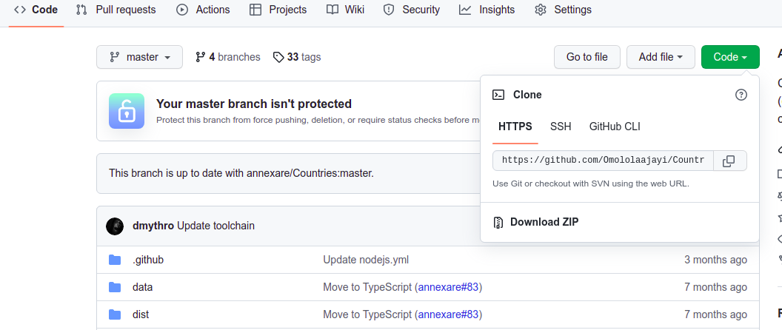

* Extracted the file on my pc and converted the files to csv file and then sql files using online software.
* Created a new database named decagon on my pc and updated the sql files into the database.

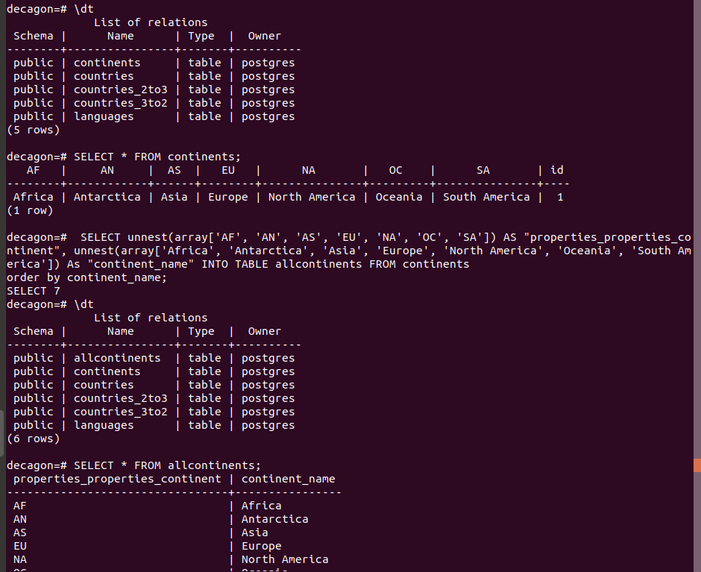

* Updated the continents table to allcontinents table for column referencing.
* Created the reports in SQL
* Continent countrycount report in SQL

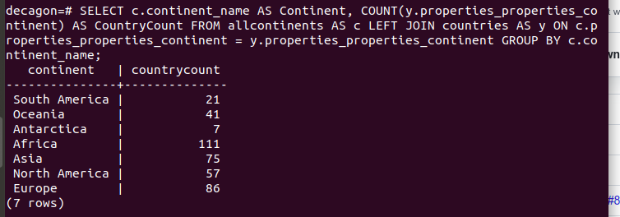

* Language Country report

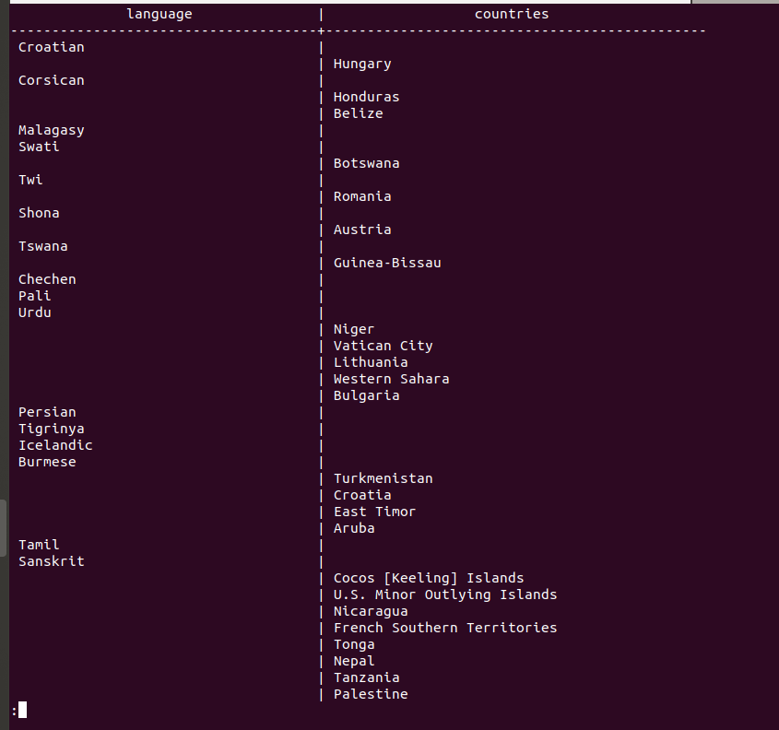

* Country Language count report

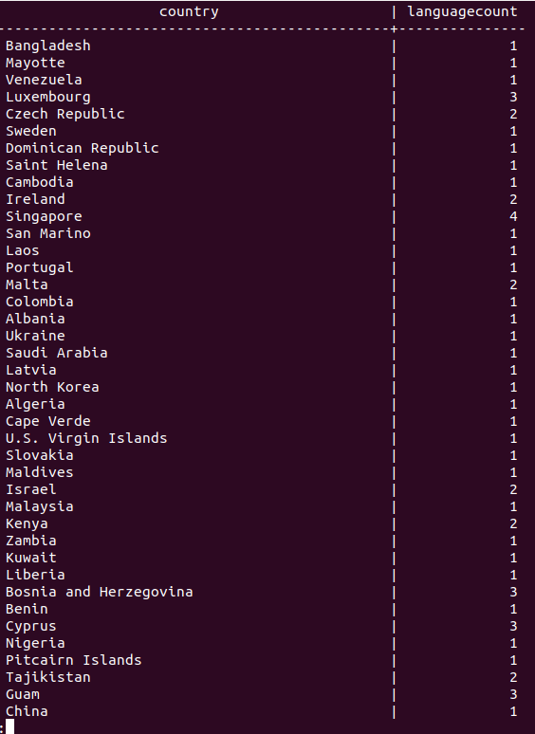

* Installed PostgreSQL on R studio and connected the database to R.
* Proceeded to run the queries on R.
* All codes from the reports are in the R script attached names Omolola Ajayi.R. Also, images of the code run on R are also included.